1. Design a contact us form with all fields as required.

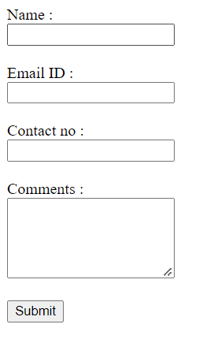

1. Use certain HTML elements to display the following in a HTML page.

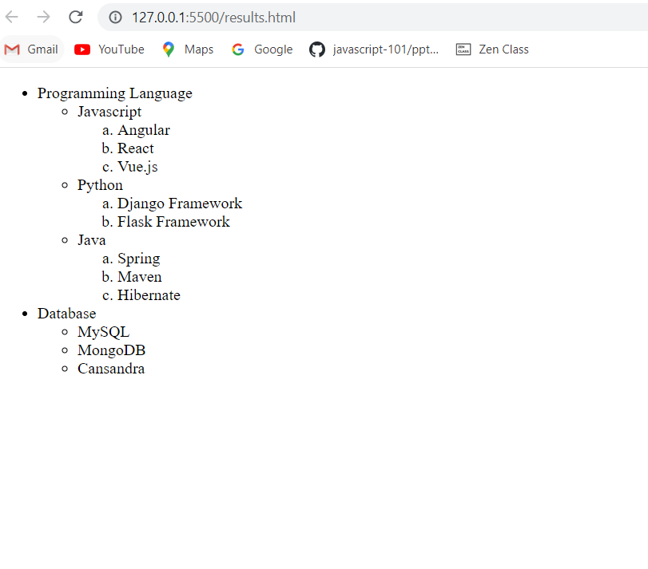

1. Create an element that helps you to open the [https://google.com](https://google.com/) in separate new tab.

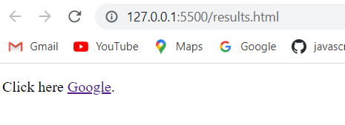

1. In the form, add two radio buttons with grouping them for employee type(Salaried and own business)

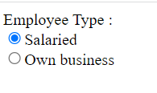

1. Design form shown in the link (<http://evc-cit.info/cit040/formguide/card_0.png>)

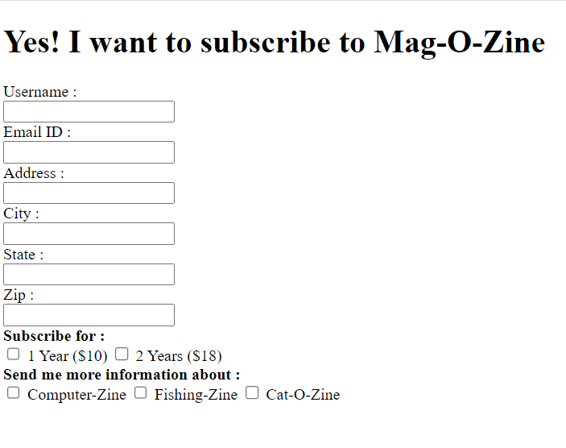

1. Use the table tag to design given image [Click here](https://www.bapugraphics.com/assets/img/port_upload_dir/table-4.jpg).

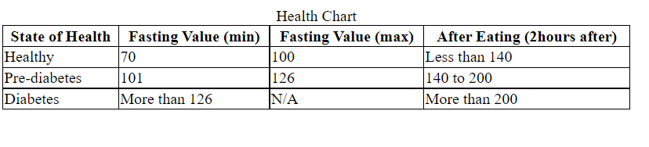

1. In your, HTML page add the below line and Highlight it without using any CSS.

* "HTML & CSS is awesome"



1. Create an HTML page, which should contain all types of input elements.

